Project 1:-

Remotely Run Commands on an EC2 Instance

In this example scenario, as a System Administrator, if we need to update the packages on your EC2 instances. To complicate this normally simple admin task, your security team does not allow everyone to direct access production servers via SSH or allow you use bastion hosts. Fortunately, you can use Systems Manager to remotely run commands, like update packages, on your EC2 instances.

To solve this challenging scenario, we will create an Identity and Access Management (IAM) role, enable an agent on your instance that communicates with Systems Manager, then follow best practices by running the AWS-UpdateSSMAgent document to upgrade your Systems Manager Agent, and finally use Systems Manager to run a command on your instance.

## **Step 1. Create an Identity and Access Management (IAM) role:-**

In this step, we will create an IAM role that will be used to give Systems Manager permission to perform actions on users instances.

a.  Open the IAM console at <https://console.aws.amazon.com/iam/>

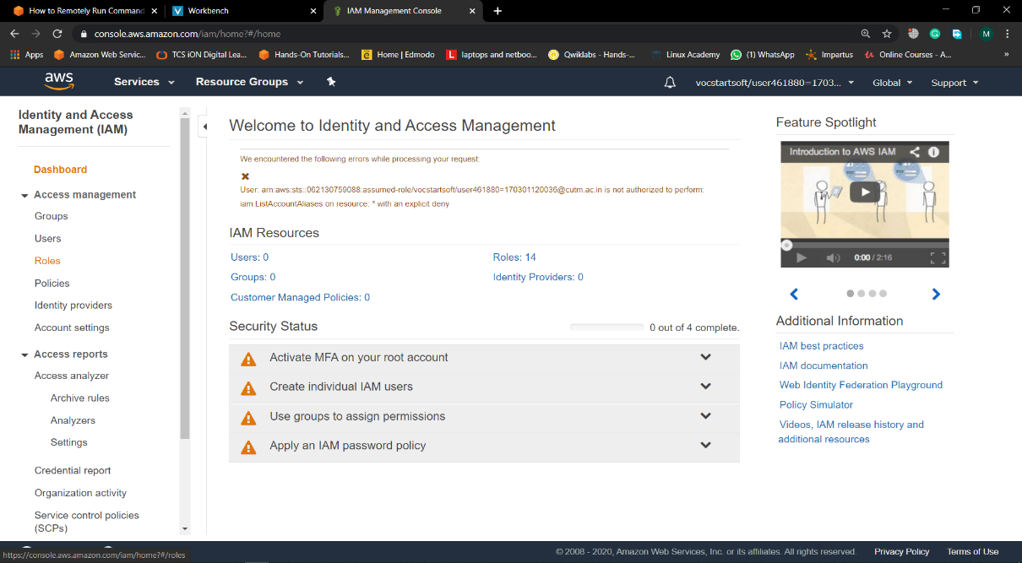

b. choose Roles, and then choose Create role.

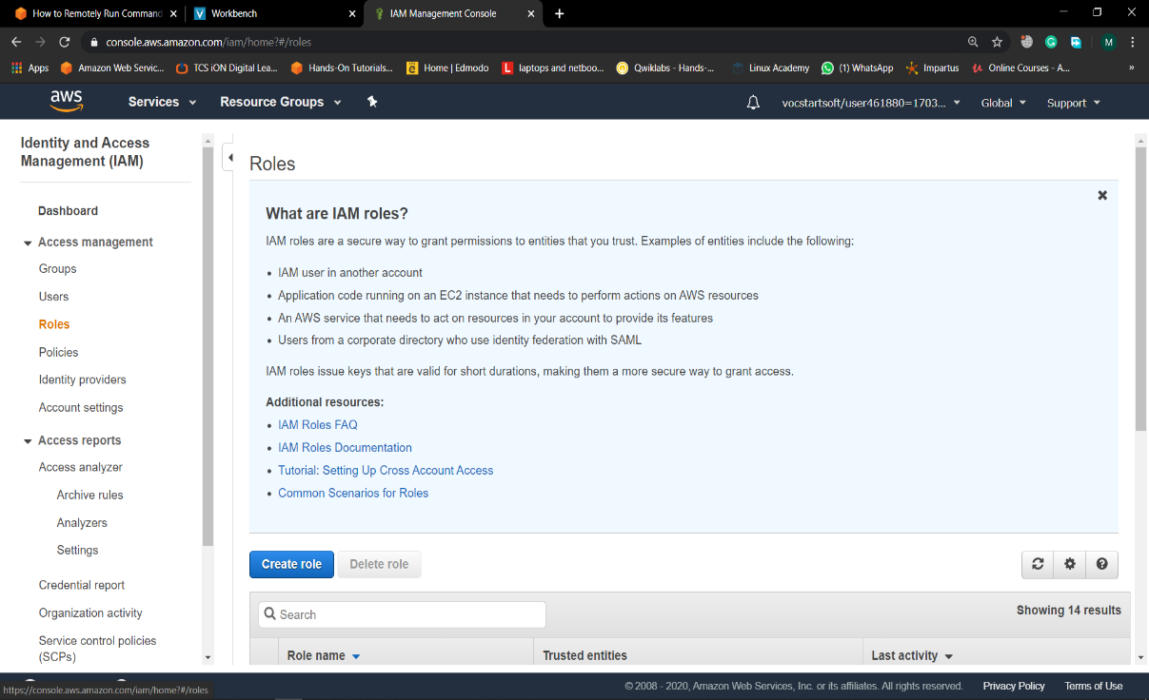

c. choose EC2, and then choose Next: Permissions

d. On the Attached permissions policy page, in the search bar type *AmazonEC2RoleforSSM* then from the policy list select AmazonEC2RoleforSSM, and then choose Next: Review.

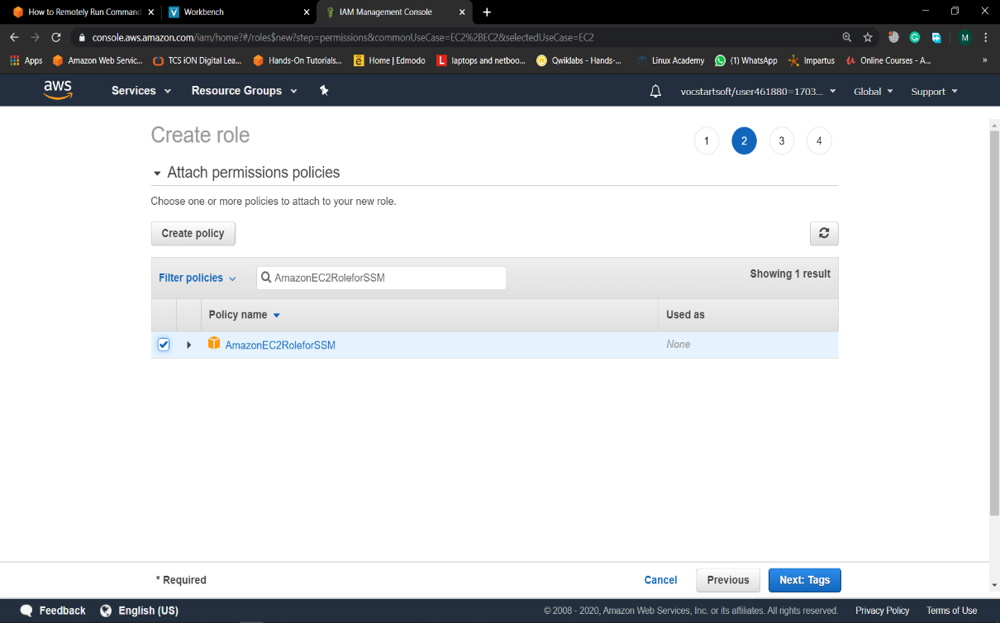

e.  On the Review page, in the Role name box type in *EnablesEC2ToAccessSystemsManagerRole*. In the Role description box type in *Enables an EC2 instance to access Systems Manager*. Choose Create role.

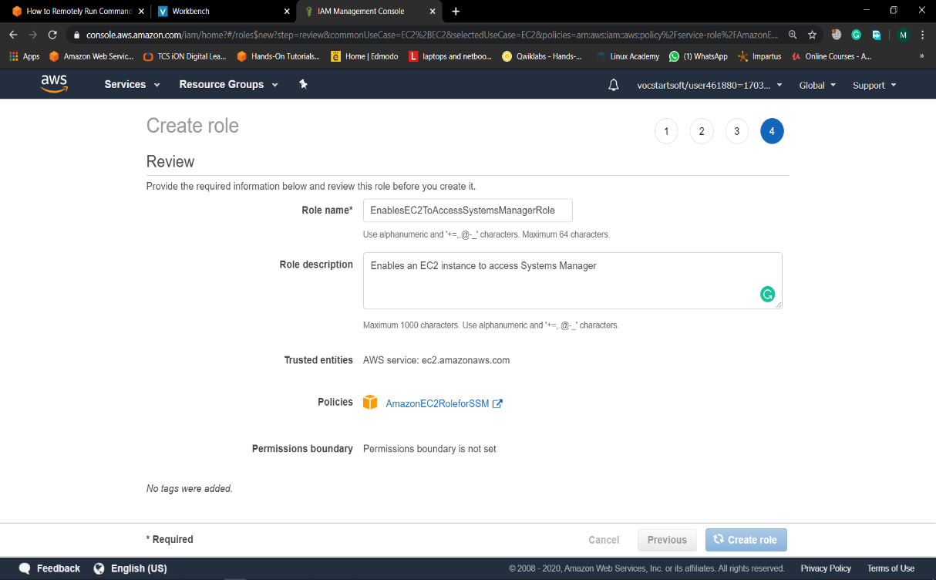

## **Step 2. Create an EC2 instance:-**

## Open the [Amazon EC2 console](https://console.aws.amazon.com/ec2/). From the EC2 console select your preferred [region](http://docs.aws.amazon.com/general/latest/gr/rande.html#ssm_region). Systems Manager is supported in all AWS Regions. Now choose Launch Instance.

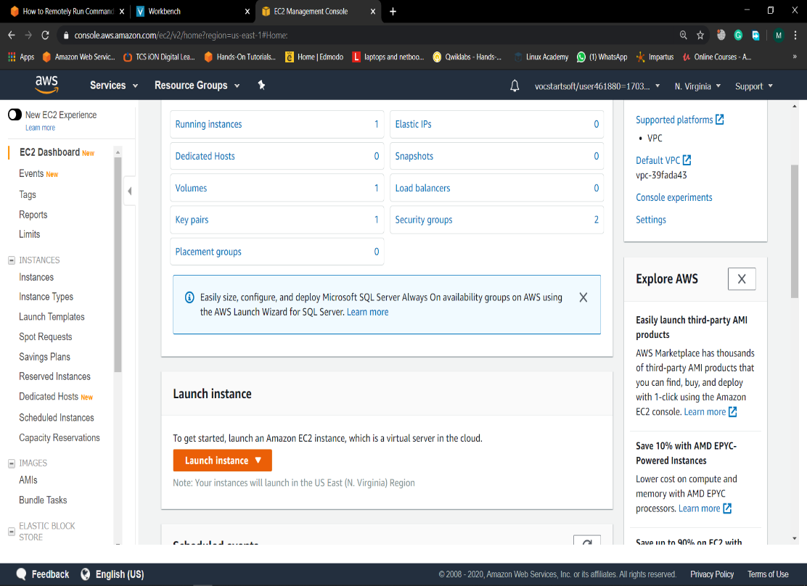

1. **choose** *Amazon Linux AMI*. Make sure to select Amazon Linux base AMI
2. **choose t2**.micro type instance then click on configuration part and choose the separeted IAM role for giving permission to access the instance.

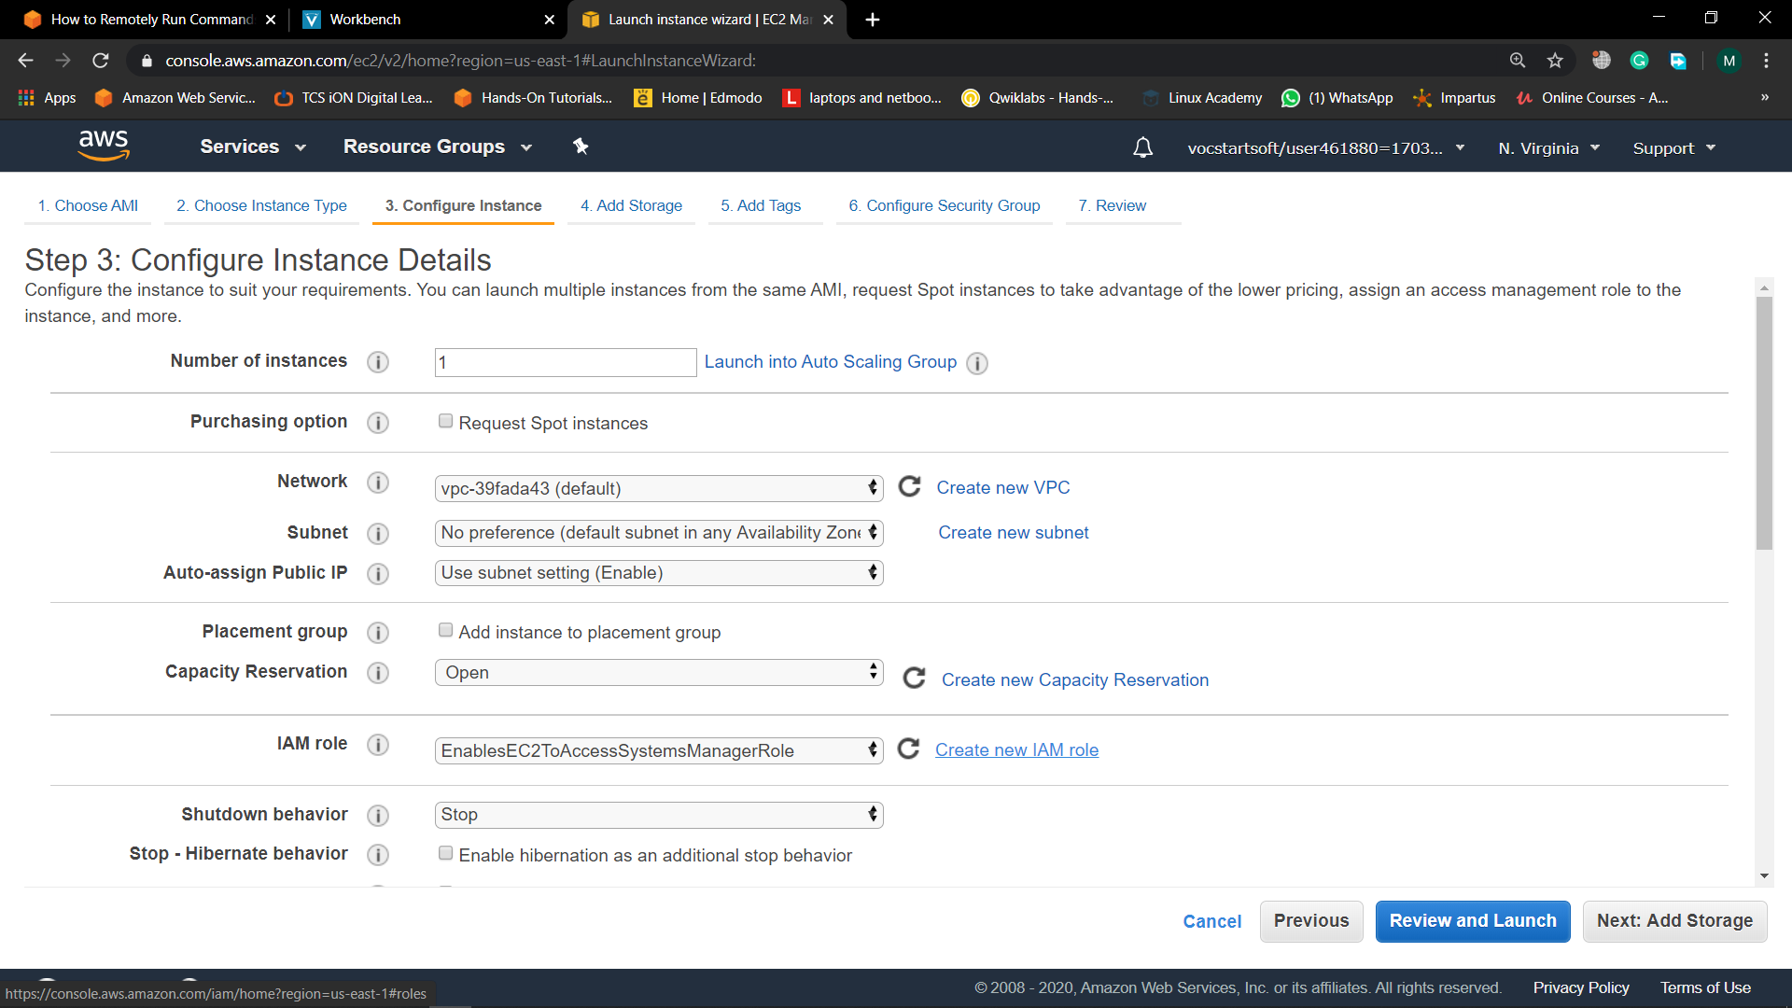

1. Then luch the EC2 instance and the choose key pair(it should be pre created or create a new key pair and configure it).

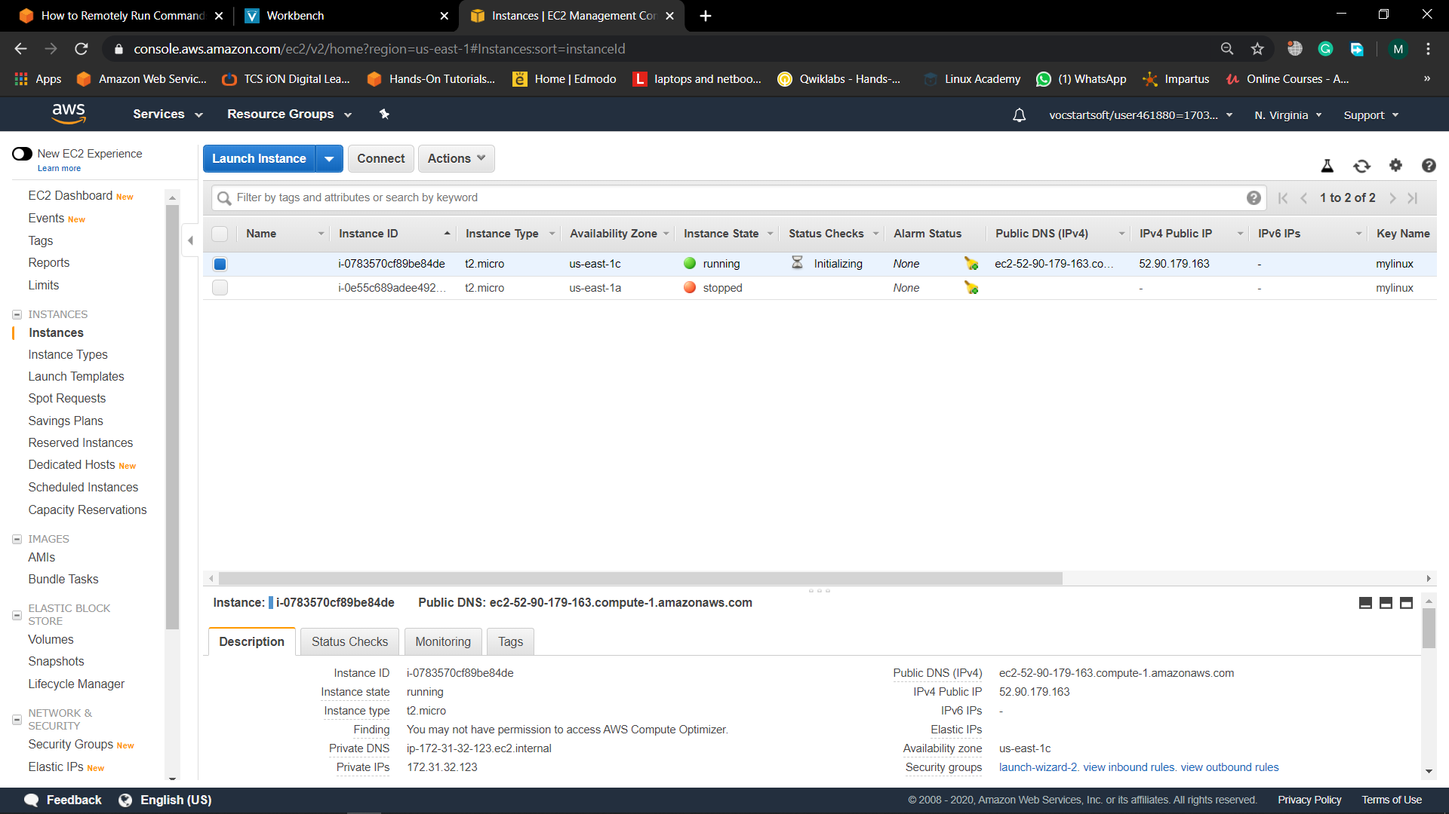

## **Step 3. Update the Systems Manager Agent:-**

1. click on Services. Then, under Management Tools, select *Systems Manager* to open the Systems Manager console.

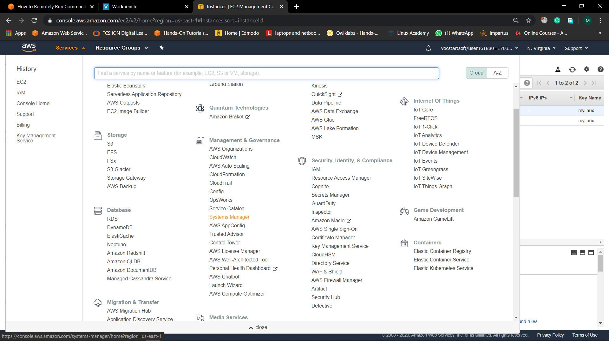

1. Under the Shared Resources section choose Managed Instances.

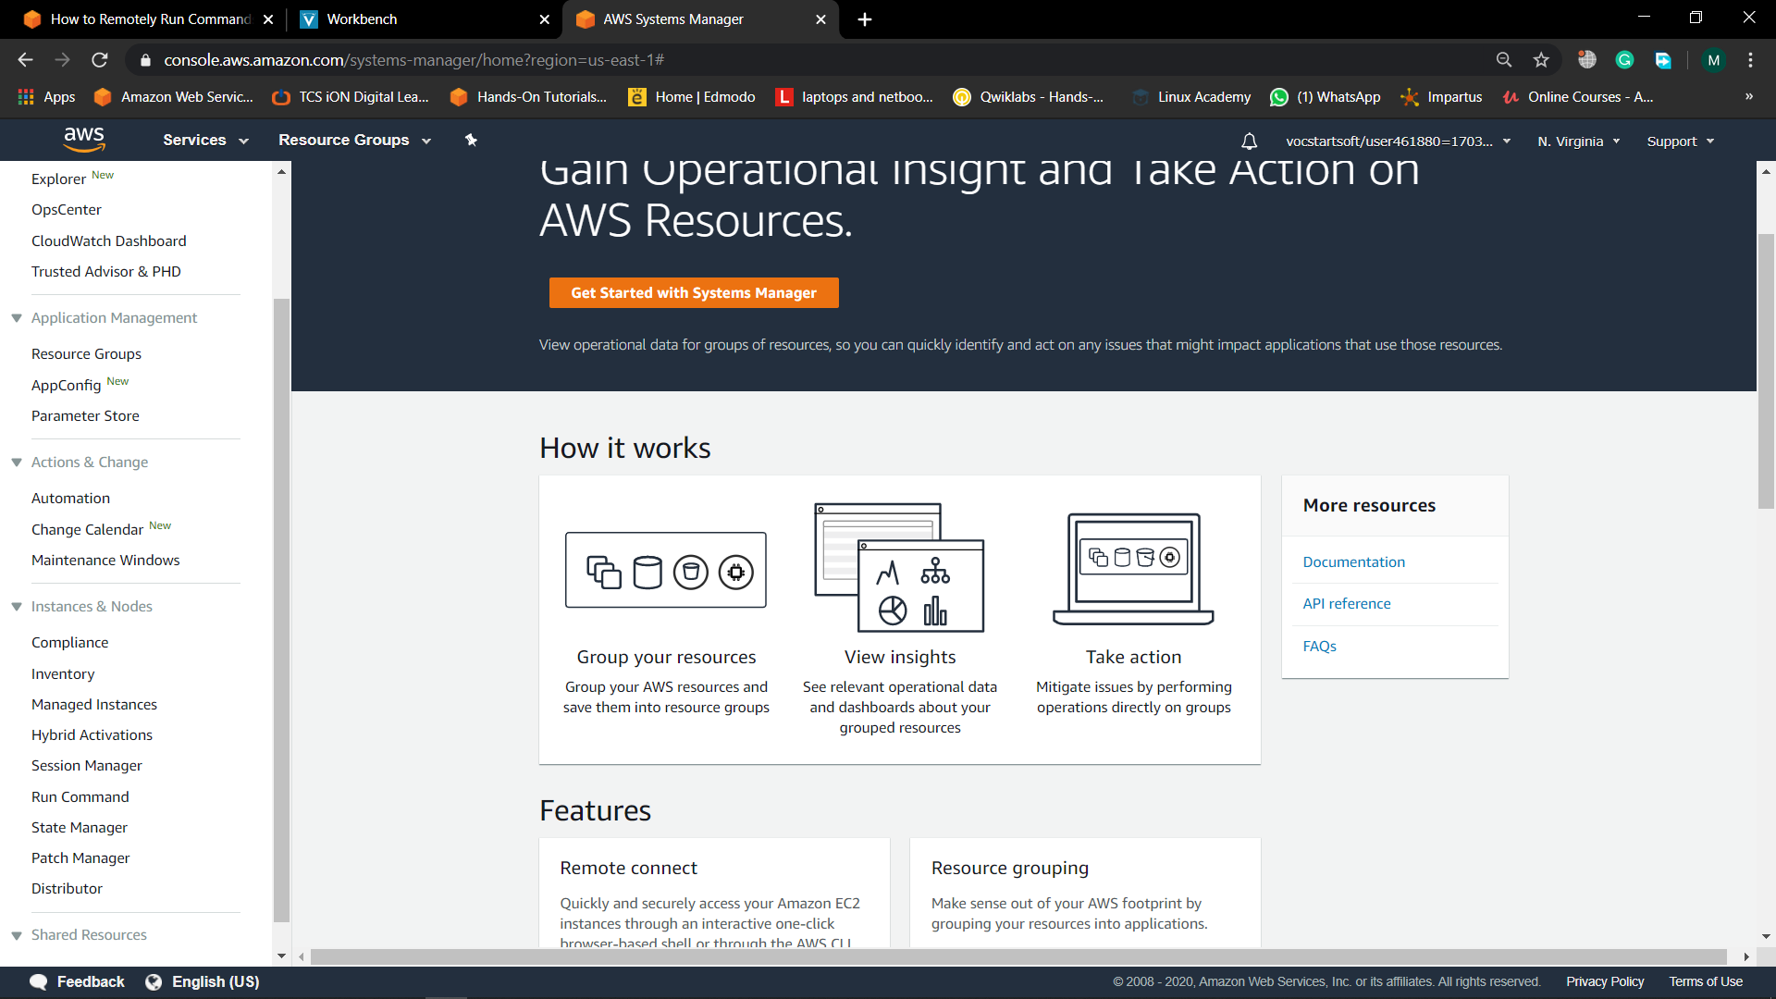

1. From Managed instances page, select Run Command.

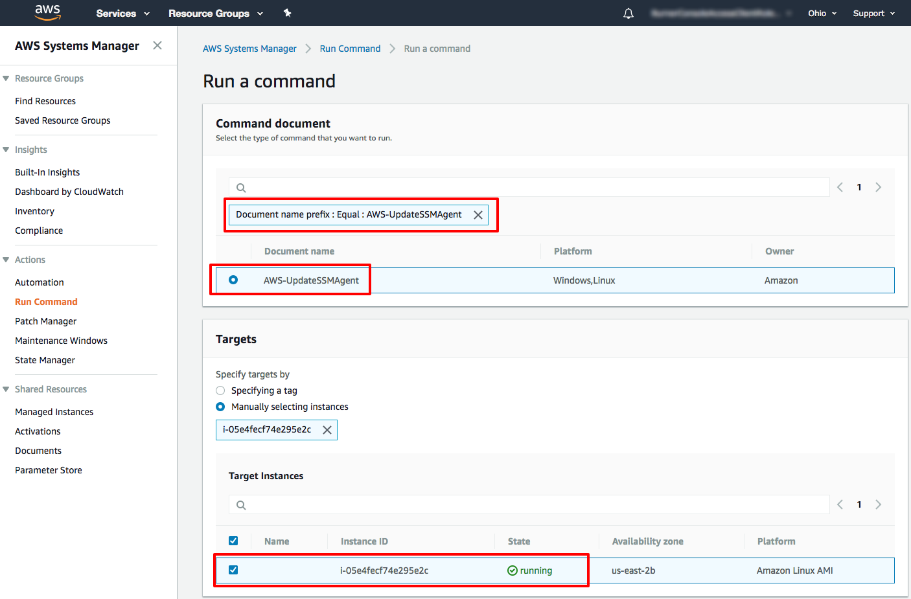

1. On the Run a command page, click in the search bar and select, Document name prefix, then click on Equal, then type in *AWS-UpdateSSMAgent*.  
     
   Now click on the radio button on the left of AWS-UpdateSSMAgent. This document will upgrade Systems Management agent on the instance.  
     
   Scroll down to the Targets panel and click the check box next to your managed EC2 instance.  
     
   Finally, scroll down and select Run.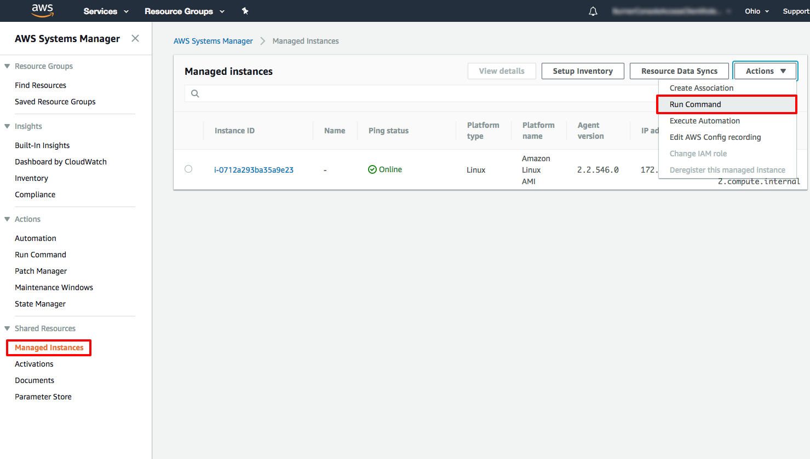

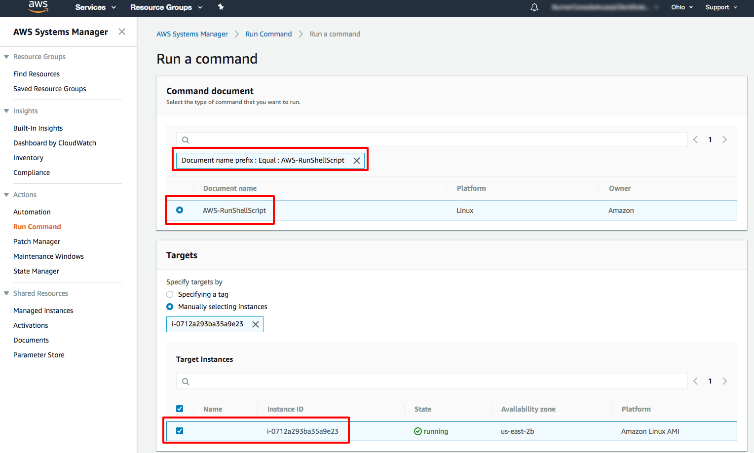

1. Next you will see page documenting your running command then and overall success in green. Congrats, you have just run your first remote command using Systems Manager.

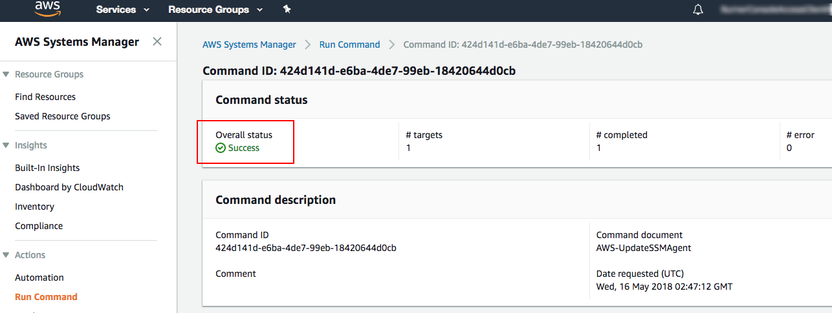

## **Step 4. Run a Remote Shell Script**

1. From the Systems Management console, in the left nav under Shared Resources select Managed instances. Then in the Actions menu, select the Run Command menu item.
2. On the Run a command page, click in the search bar and select, Document name prefix, then click on Equal, then type in *AWS-RunShellScript*.  
     
   Now click on the radio button on the left of AWS-RunShellScript. This document will upgrade Systems Management agent on the instance.  
     
   Scroll down to the Targets panel and click the check box next to your managed EC2 instance.

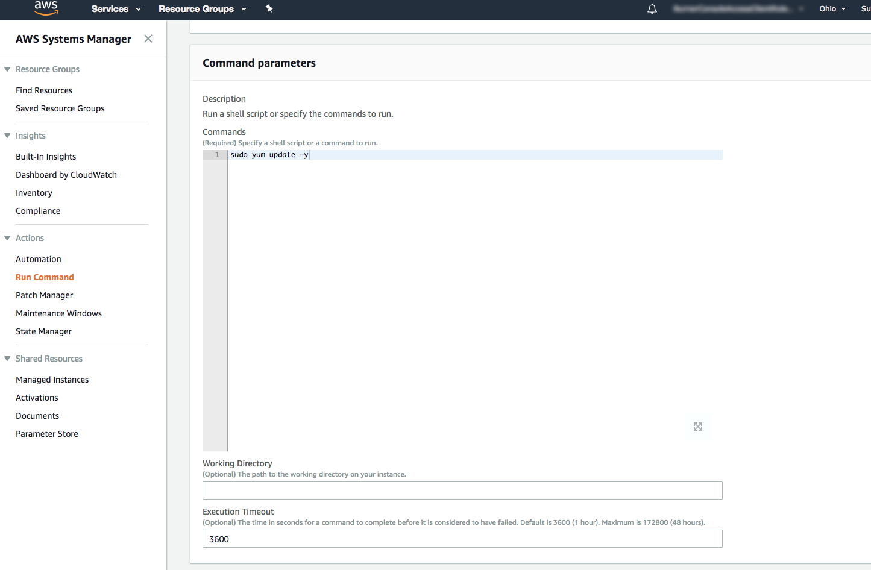

1. Scroll down to the Command Parameters panel and insert the following command in the Commands text box:  
     
   sudo yum update -y  
     
   Finally, scroll down and select Run

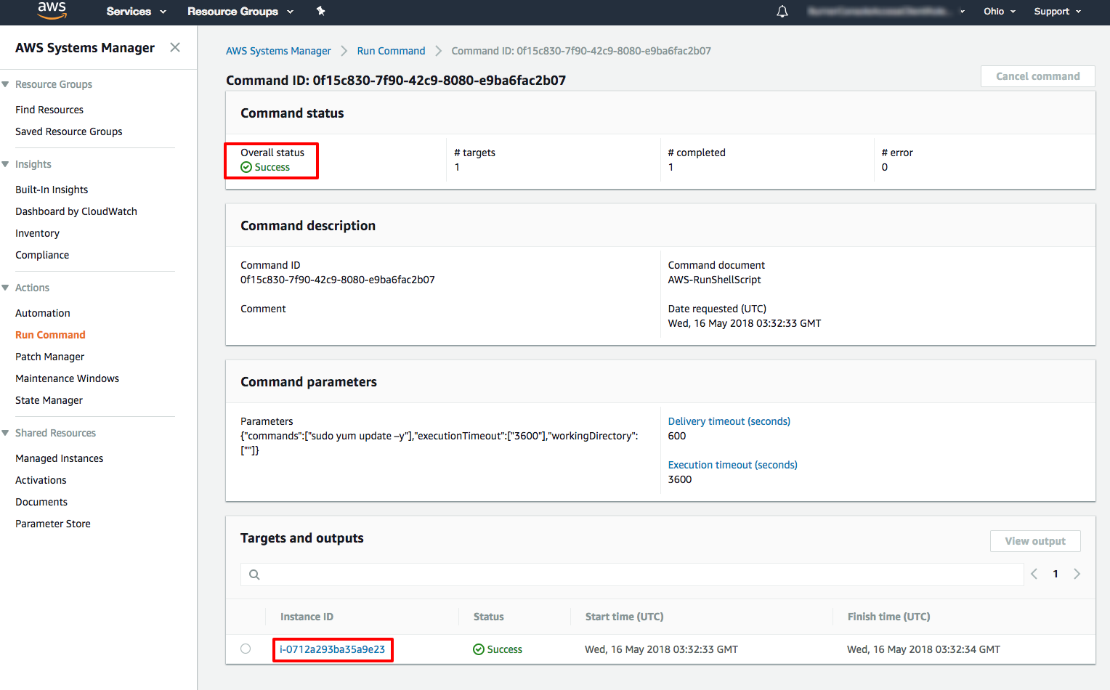

1. From the Output on: i-XX page click on the header of the Step 1 - Output panel to view the output of the update command from the instance.

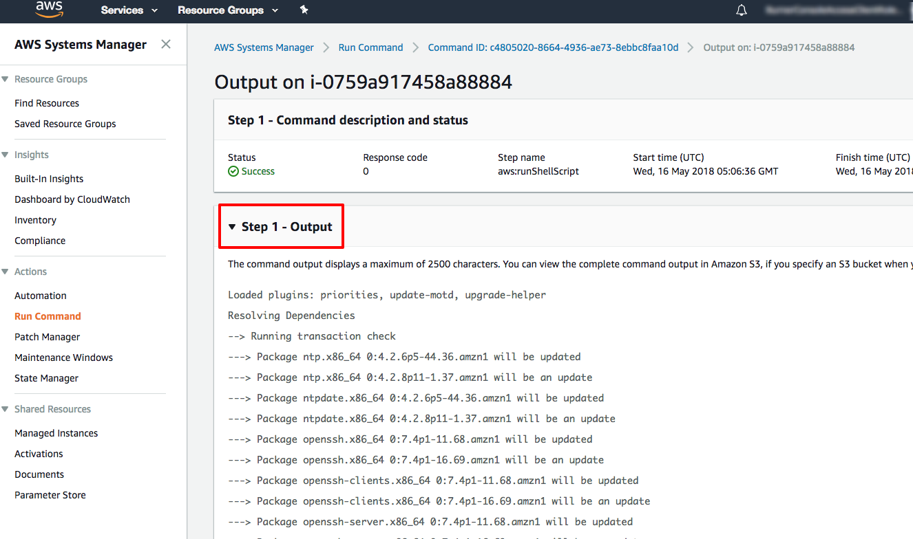

**Step 5. Terminate Your Resources:-**

1. Open the [Amazon EC2 console](https://console.aws.amazon.com/ec2/) and from the left nav under the Instances heading select Instances.

b.  Select your instance's checkbox and click Actions, then Instance State, then Terminate. This will terminate your instance completely.

